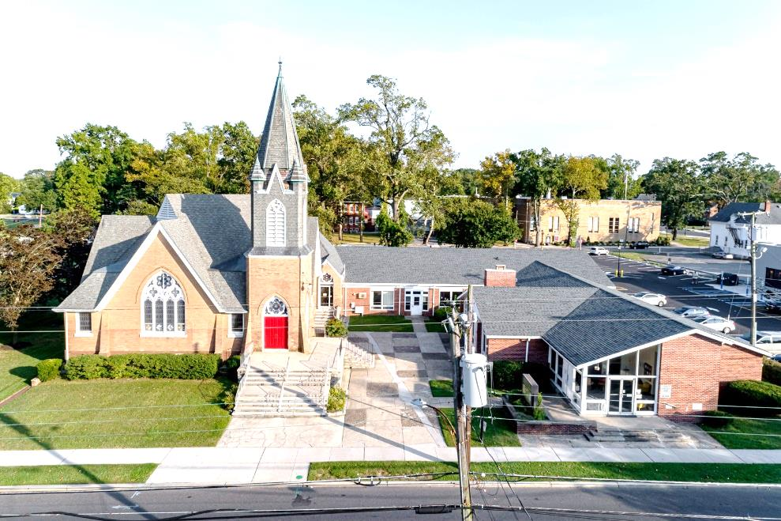

The Presbyterian Church at Hammonton
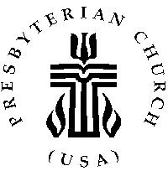

Our vision is to open our doors to all seeking a spiritual home of worship and to carry the light and love of Jesus Christ, our Savior, throughout the community.

MISSION STATEMENT
We are committed to Jesus Christ and the growing of his Church by glorifying God and by proclaiming the good news of the gospel through word and deed. We involve and reach out to our members and our community in Christ’s name through worship, Christian Education, and stewardship to support the mission of our church.

Note: Special thanks to Rev. Dr. Patricia Epprecht for leading us in worship today.

Organist: Cindy Birnbaum
Sunday School Superintendent: Beth Burkett-Rice

2022 2023 2024
ELDERS
Eric Copenhaver Dorrine Esposito Sallye Hershman
Marylee Kondrach Richard Walker Paul Moul
Charles Muller Johanna Johnson

DEACONS
Elsie Bakley Wendy Copenhaver Hilda Lugo
Nancy Foster Ann DiMeo Carol Orsi
Margaret Jones Rebecca Lindstrom Rebecca Villani

Clerk of Session: Beth Burkett-Rice

Church Office: 326 Bellevue Avenue, Hammonton, NJ
Office hours: Tuesday - Thursday 9:30 AM to 12:30 PM
Phone (609) 561-0168 ~ Fax (609) 561-6105
e-mail: office@hammontonpres.org
website: www.hammontonpres.org

THE CELEBRATION OF WORSHIP
NOVEMBER 27TH, 2022
1ST SUNDAY OF ADVENT
VIRTUAL & LIVE SERVICE
11:00am
****************************************************
~ GATHERING IN GOD’S NAME ~
“Welcome to the Presbyterian Church at Hammonton, we are glad you are able to join us. As we gather for worship feel free to pray and meditate on God’s calling in your life. Be respectful of others around you who might be doing the same, prior and during the Prelude, keeping your voice and conversation soft and to a minimum.”
The days are coming, says the Lord, When I will fulfill the promise:
I will cause a righteous Branch to spring up for David;
And he shall execute justice and righteousness.
- Jeremiah 33:14a, 15

PRELUDE “Come Thou Fount of Every Blessing”- E. Broughton
“O Come, O Come Emmanuel”- M. Thomas
“Hark! A Thrilling Voice is Sounding” – W. Monk

~ TIME FOR CENTERING STILLNESS AND SILENCE ~

WELCOME AND ANNOUNCEMENTS

*THE PEACE
Let the people greet one another by staying in their seats and saying: “Peace be with you!”

INTROIT
~ HUMBLY APPROACHING GOD ~

OPENING PRAYER
Gracious God, send us your grace this Advent Season so that
we can prepare for your coming. Touch our hearts with longing so that we can better love and serve you and each other. Fill us with the hope that we can be transformed by your Spirit and so help transform the world. Give us the peace of knowing that you came to share our human life and redeem us for the sake of love. We ask these things in the name of Jesus whose kingdom we seek. Amen.

*CALL TO WORSHIP
One: This is the New Year for the church of Jesus Christ.
All: We come into Advent waiting and watching for the Christ to come.
One: Maybe this year will be a year of promised peace.
All: Peace. The sound of Peace is wonderful to hear.
Peace in the world. Peace among our neighbors. Peace in our hearts.
One: Will peace come? Will we see a new day of love and caring?
All: Only the Prince of Peace can bring that to us.
Come into our midst, God’s anointed one.
Come into our hearts, Peacemaker.
Come into our lives, Saving Lord.

*HYMN #2010 ~ “Praise Ye the Lord”

LIGHTING OF ADVENT CANDLES~ Frank &
RoseMarie Reid
CALL TO CONFESSION

PRAYER OF CONFESSION (unison)
God of all time and seasons, how quickly the year spins by and we are caught unprepared for your advent. We are still recovering from Thanksgiving or the latest crisis or the long list of things to do. The demands on our time seem unending, the tasks seem overwhelming and our energy is draining.
Holy God, sing to us in the stillness of this moment, speak to us in the depths of our hearts. Let there be a space for you in the midst of all the hurry and rush, a holy, inner place that cherishes silence and song, that keeps a candle lit and a manger ready. God of all time and seasons, create in us a place for your birth. (silent confession)

ASSURANCE OF FORGIVENESS

*GLORIA PATRI

ANTHEM~ “Prepare Ye the Way of the Lord”

CHILDREN’S MESSAGE

~ RECEIVING GOD’S WORD ~

PRAYER OF ILLUMINATION

SCRIPTURE READINGS Psalm 86:1-7 (OT, pg 522)
Matthew 1:18-25 (NT, p 1)

MESSAGE ~ “In Memory My Big Brother”
- Rev. Dr. Patricia Epprecht
Text: When Joseph awoke from sleep, he did as the angel of the
Lord commanded him; he took her as his wife, but had no
marital relations with her until she had borne a son; and he named him Jesus. Matt 1:24 – 25

~ RESPONDING TO THE WORD ~

*HYMN #2022 ~“Great Is the Lord”

*SAYING WHAT WE BELIEVE -Col. 1:15-20
Jesus Christ is the image of the invisible God, the firstborn of all creation; in him all things in heaven and on earth were created, thing visible and invisible.
All things have been created through him and for him.
He himself is before all things, and in him all things hold together, He is the head of the body, the church; he is the beginning, the firstborn of the dead, so that he might come to have first place in everything.
For in him all the fullness of God was pleased to dwell, and through him God was pleased to reconcile all things, whether on earth or in heaven, by making peace through the blood of his cross. Amen

JOYS AND CONCERNS OF THE CHURCH

PASTORAL PRAYER & LORD’S PRAYER
Our Father, who art in heaven, hallowed be Thy name. Thy kingdom come, thy will be done, on earth as it is in heaven. Give us this day our daily bread; and forgive our debts as we forgive our debtors; and lead us not into temptation, but deliver us from evil. For Thine is the kingdom and the power and the glory, forever. Amen.

THE OFFERING OF OUR GIFTS AND OURSELVES

OFFERTORY ~ “Come Thou Long-Expected Jesus” -G. Macchia

*DOXOLOGY (#592)
Praise God, from whom all blessings flow; Praise Him, all creatures here below; Praise Him above, ye heavenly host; Praise Father, Son, and Holy Ghost. Amen.

OFFERTORY PRAYER

~ GOING IN GOD’S NAME ~

*HYMN #2008~ “Let All Things Now Living”

*THE CHARGE AND BENEDICTION

POSTLUDE~ “People Look East”- S. Aber

OUR WORSHIP HAS ENDED, LET OUR SERVICE BEGIN
*Signifies stand if comfortable.

Last Week’s Attendance & Offering:
Attendance: 47 people Offering: $2,658.00
______________________________________________
CHURCH EVENTS
>>>THIS WEEK:
Sunday-11/27: Adding a new member:
Barbara Stutzbach
Monday-11/28:
9:00 AM Clothing Closet
-12:00 PM
7:30 PM ESL classes

Tuesday-11/29:
9:00 AM Clothing Closet
-12:00 PM

Wednesday-11/30:
9:00 AM Clothing Closet
-12:00 PM
7:30 PM ESL classes

Saturday-12/03: Craft Night w/ games & refreshments,
After the town tree lighting ceremony
______________________________________________
>>UPCOMING:
Monday-12/05:
9:00 AM Clothing Closet
-12:00 PM
7:30 PM ESL classes

Tuesday-12/06:
9:00 AM Clothing Closet
-12:00 PM

Wednesday-12/07:
9:00 AM Clothing Closet
-12:00 PM
7:30 PM ESL classes

Thursday-12/08:
7:00 PM Session Meeting
______________________________________________

BIRTHDAYS:

December 1 Erika Lower
______________________________________________
ANNIVERSARIES:

No anniversaries this week.

SERVING YOU TODAY:

Liturgist: Bill Towne

Ushers: Eric Copenhaver, Captain
John Bock
Matthew Hershman
Theresa Stubbe
Ann DiMeo
Becky Villani

**Children’s Church: Donna Brown
Next week: Wendy Copenhaver

